- Program ID : VB003MA1

- Display Layout
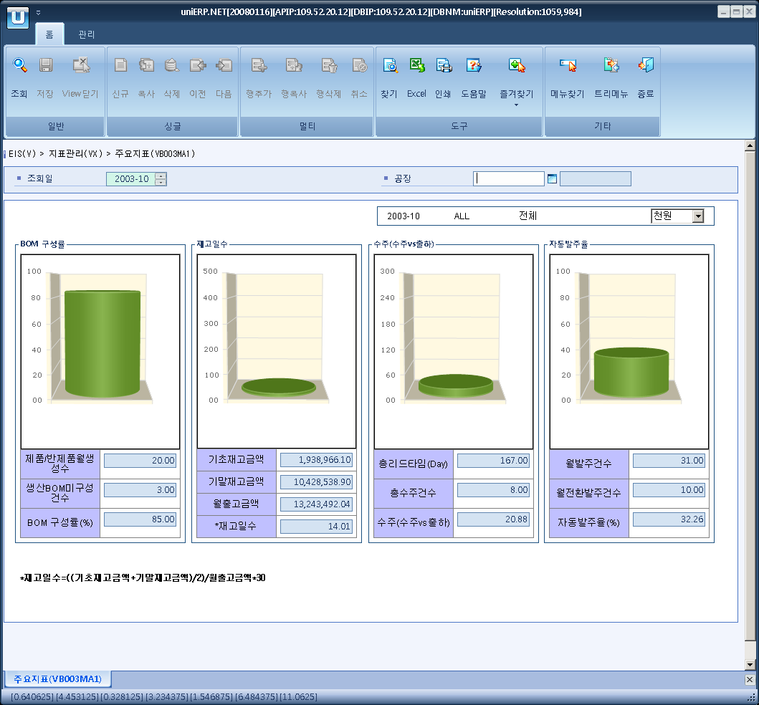

- Event flow
- Click Query button
- OnFncQuery -> DbQuery -> DataChange
- Display Unit combo change
- uniCombo1_ValueChanged -> DataChange

- SQL Statements
- Production BOM composition rate
SELECT SUM(VB0030T.TOT_CNT), SUM(VB0030T.NOR_CNT), SUM(VB0030T.RATE)
FROM VB0030T
WHERE VB0030T.SP_ID = @strSpId
AND VB0030T.YYYYMM = @strYYYYMM
AND VB0030T.INDEX_CD = 'P03'

- Inventory Cycle Date
SELECT SUM(VB0030T.TMP1_CNT), SUM(VB0030T.TMP2_CNT), SUM(VB0030T.TMP3_CNT), SUM(VB0030T.RATE)
FROM VB0030T
WHERE VB0030T.SP_ID = @strSpId
AND VB0030T.YYYYMM = @strYYYYMM
AND VB0030T.INDEX_CD = 'I06'

- Sales Order
SELECT SUM(VB0030T.TOT_CNT), SUM(VB0030T.NOR_CNT), SUM(VB0030T.RATE)
FROM VB0030T
WHERE VB0030T.SP_ID = @strSpId
AND VB0030T.YYYYMM = @strYYYYMM
AND VB0030T.INDEX_CD = 'B01'

- Auto P/O rate
SELECT SUM(VB0030T.TOT_CNT), SUM(VB0030T.NOR_CNT), SUM(VB0030T.RATE)
FROM VB0030T
WHERE VB0030T.SP_ID = @strSpId
AND VB0030T.YYYYMM = @strYYYYMM
AND VB0030T.INDEX_CD = 'M01'

